# **Chapter 3: Development Methodology**

## **3.1 Description of the Methodology**

There are many methods for developing a system. Over various methodologies, this project will be develop under **Waterfall Model** design methodology.

### **Waterfall Model:**

A model where linear and sequential approaches are under taken for system development is a waterfall model. The system is develop systematically from one-step to another in downward manner without iteration to previous steps. This means every phase has to be completed before proceeding to the following one. This is the reason to term this methodology of system development as waterfall model.

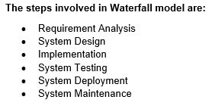



## **Advantages of Waterfall Model:**

* Waterfall model is easy to use, simple and understandable.
* It is easy to maintain because each phase has specific outputs and review process.
* It is appropriate for small projects.
* Procedure of testing is easier and more transparent.

## **Disadvantages of Waterfall Model:**

* Requirements are not completely mention.
* Time-consuming methodology.
* Lack of flexibility in the system.
* Risk and uncertainty are high.

## **3.2 Design Pattern**

Over different design patterns, this project **Mark Sheet Generator** will be using **Model View Controller (MVC)** design pattern.

* **Model:**The Model is, simply put, the module, which handles the data of the program. It could be, for example, a module, which interacts with a database.
* **View:**The View is the module whose task is to display data to the user. It does not have any functionality in itself, other than what is needed to transform and lay out the data as needed by the display format. In other words, the View acts as an interface between the display (which can be a physical display or e.g. a document format) and the rest of the program, and doesn't have any functionality related to anything else than displaying the data.
* **Controller:**

The Controller is the core module, which makes all the decisions. It has all the relevant functionality of the program and interacts with the Model and the View, commanding them and passing data between them as needed.

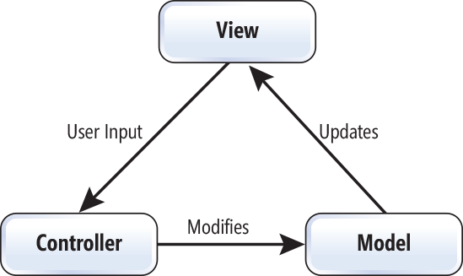

### **Advantages of MVC pattern:**

* MVC pattern helps in attaining easy maintenance, applying loose coupling, and reducing complexity.
* MVC allows independent changes on the frontend without any, or very few, changes on the backend logic, and so the development efforts can still run independently.
* Model or business logic can be changed without any changes in the view.
* Helping the developers for developing system that loads very fast as it supports asynchronous technique.

### **Disadvantages of MVC pattern:**

* Due to three layers, it can increase the complexity.
* There is deficiency of efficiency of data access in view layer.

## **3.3 Architecture**

The **Mark Sheet Generator** system will be using two- tier architecture.

**Two- Tier architecture:**

The two- tier architecture is based on Client Server architecture. It is like client server application. The direct communication takes places between client and server application. Due to tight coupling a 2 tiered application will run faster.

**The Two-tier architecture is divided into two parts:**

1. Client Application (Client Tier)

2. Database (Data Tier)

Client system handles both Presentation and Application layers and Server system handles Database layer. It is also known as client server application. The communication takes place between the Client and the Server. Client system sends the request to the Server system and the Server system processes the request and sends back the data to the Client System



 

 